Cycle Plan
The last part of the Engagement Meeting is Planning, or the act of creating the Cycle Plan. The Cycle Plan is simply a collection of all the tasks we intend to do during the Cycle in order to deliver value. We ask questions and discuss what is required to complete each Value Driver, and we deliberately use our Reflections and Learnings to shape our understanding of the intended outcomes. A Cycle Plan should be tempered with a truthful assessment of our capacity to complete the tasks. Consultative Decision-Making is used to create the Cycle Plan.

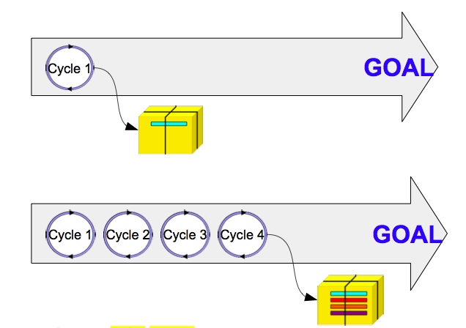

Note: The coloured bars indicating the output of each Cycle represent completed Value Drivers.

(From the OpenAgile Primer)

